**US Housing Market Analysis & Insights: 2008 – 2019**

Seasonally Adjusted Median Sales Prices Over Time

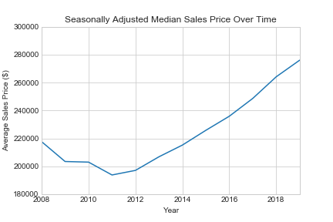

Percentage of Foreclosure Resales

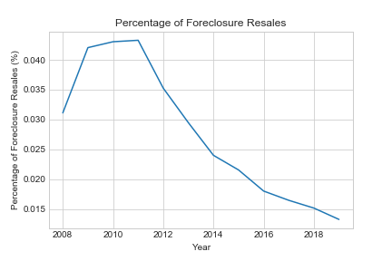

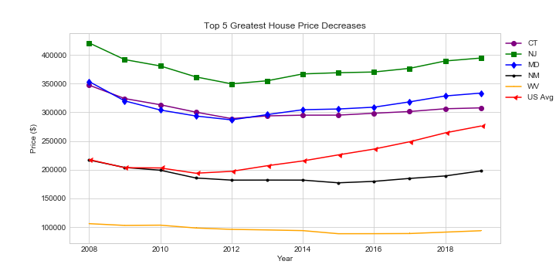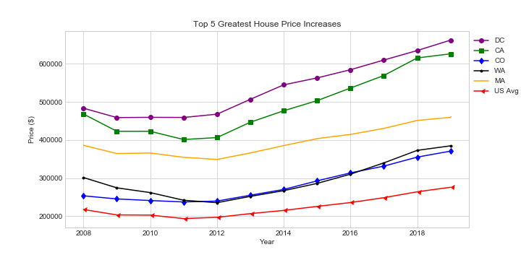Top 5 Greatest House Price Increases 2008 – 2019

DC and Connecticut Variable P-Values

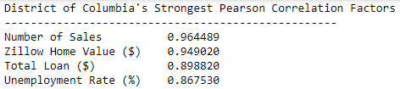

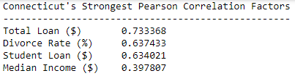

DC Median Sales Price Variable Plots

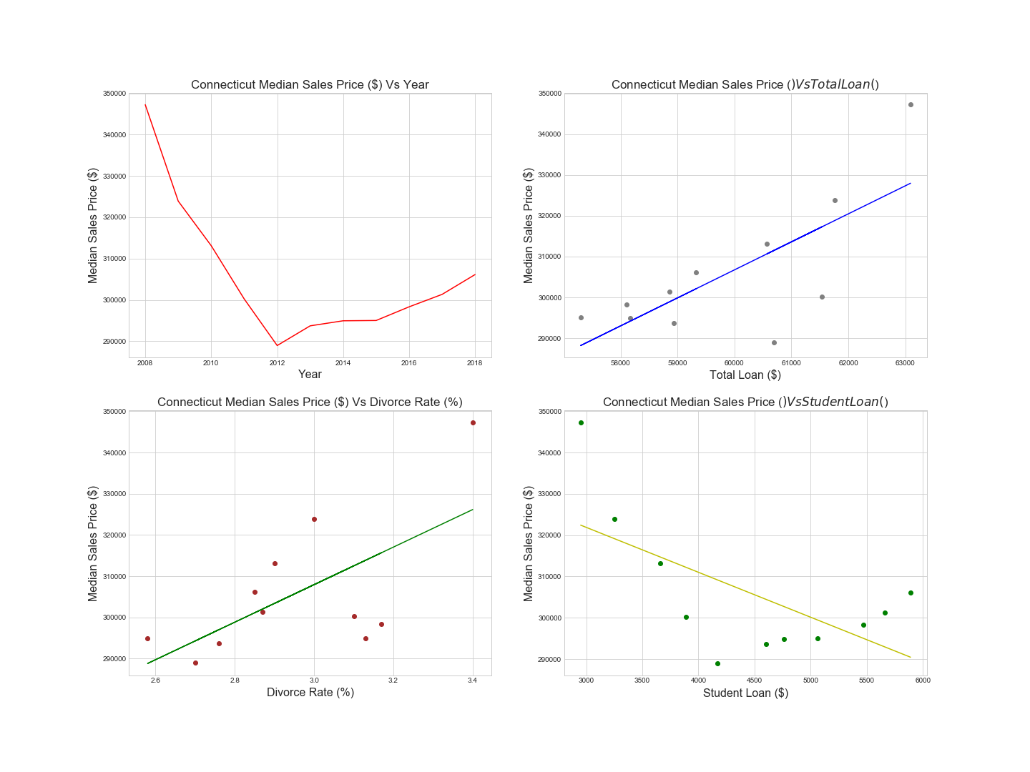Connecticut Median Sales

Predicted 2020 Median Sales Prices for DC and Conneticut

